**Lab 9**

-- Create a trigger that will help to keep a record copy in table (Employee_History) for any new record will be inserted in the employee table.

**3.**Write a code that will create new table named “Employee_History” where it should exactly look like the employee table that you have created (but without inserting data). Take a screenshot for this code.

**CREATE TABLE Employee_History (E_ID INT, E_Name VARCHAR(25), E_Specialization VARCHAR(25));**

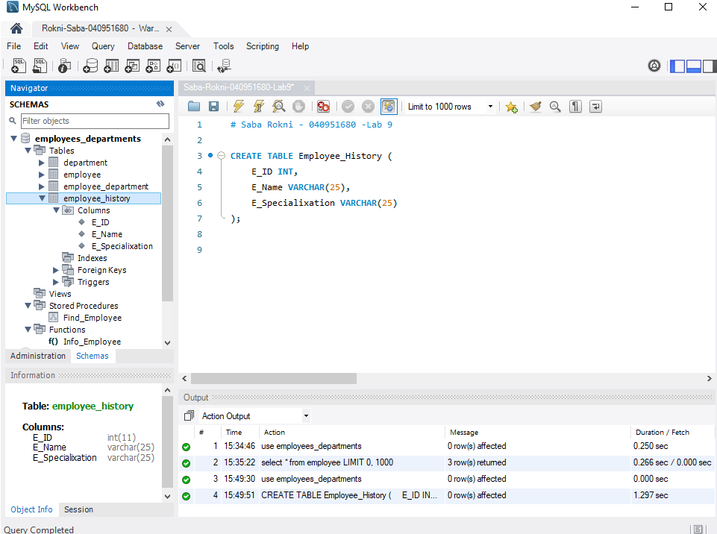

**4.**Write a code that will create the required trigger above. Take a screenshot for this code.

**delimiter !!**

**create trigger employee_history**

**after insert on employee**

**for each row**

**begin**

**insert into employee_history(E_ID,E_Name,E_Specialization)**

**value(new.E_ID,new.E_Name,new.E_Specialization);**

**end !!**

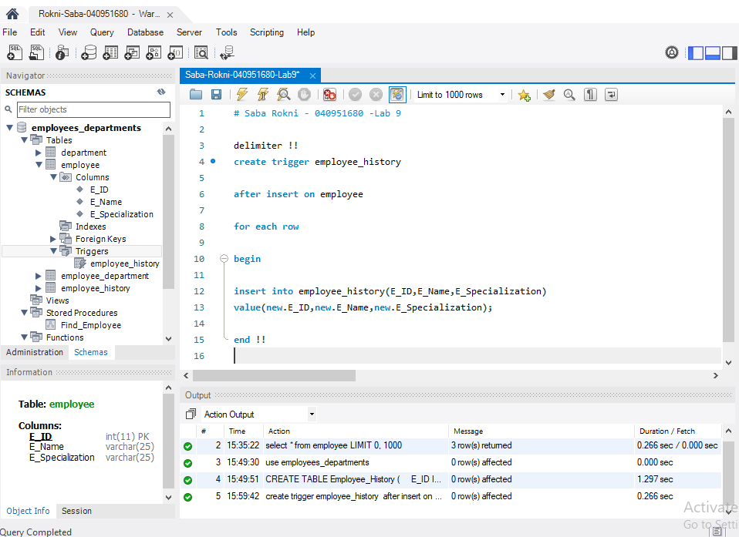

**5.** Write a code that will Insert a new record into the employee table. Take a screenshot for this code.

**insert into employee (E_ID,E_Name,E_Specialization)**

**value(44,'Sara','Consultant');**

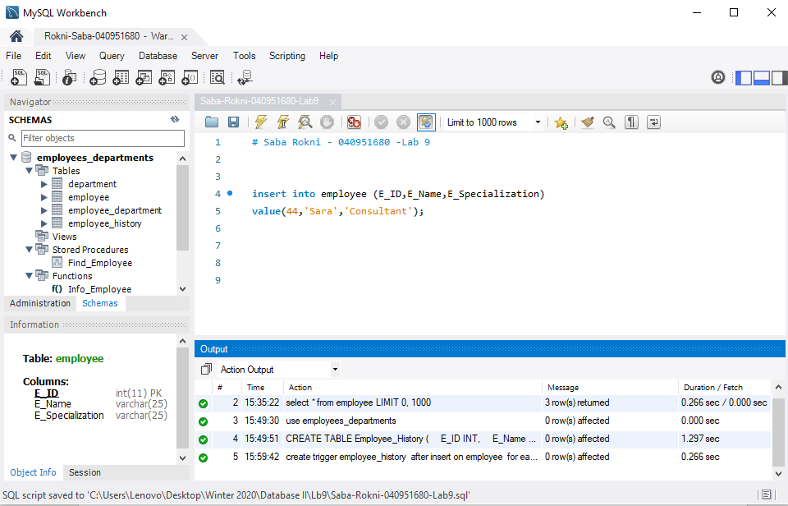

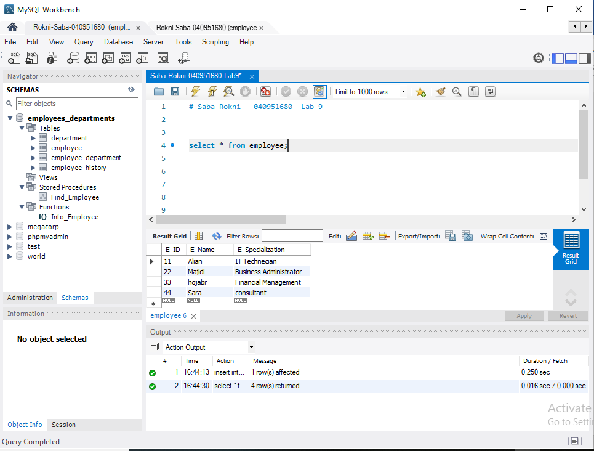

**6.**Write a code to show all the data in the Employee_History table. Take a screenshot that will show the code and the resulted table of the query.

**select * from employee_history;** 